**CS 487 – SOFTWARE ENGINEERING**

**Homework – 2**

**Suhas Palani A20548277 [spalani3@hawk.iit.edu](mailto:spalani3@hawk.iit.edu)**

**Title: AI Audio System**

The AI Audio System, an advanced in-car entertainment solution that uses artificial intelligence to provide a personalized audio experience. Key features include mood-based content selection, multi-modal interaction (voice, touch, gesture), and emotional awareness through sensors. The system adapts to user preferences over time, integrating multiple audio sources (satellite, terrestrial radio) for a seamless experience. By responding to occupants' emotional states and preferences, the AI Audio System creates a more engaging and personalized environment.

1. **Context Model**

This context diagram shows the AI Audio System at the centre, with its various partners:

* **Occupants:** They interact with the system by making requests and receiving audio output.
* **Emotion Sensors:** These provide emotion data to the system.
* **Satellite Radio:** These provide content to the system.
* **User Preferences Database:** This stores and provides user preference data.
* **Terrestrial Radio:** This also provides content to the system, offering an alternative source to satellite radio.
* **External Systems:**
* Satellite Radio (SR)
* Terrestrial Radio (TR)
* User Preferences Database (UP)

These are considered external systems because they are separate, complex systems that the AI Audio System interacts with but doesn't control directly. They provide services (content or data storage/retrieval) to our system.

* **External Input Devices:**
* Emotion Sensors (ES)

Emotion Sensors are classified as external input devices because they only provide input to the AI Audio System. They capture data about the occupants' emotional states and feed this information into the system, but don't receive any output from it.

* **External I/O (Input/Output) Devices:**
* Occupants (OC)

The Occupants are considered an external I/O because they both provide input to the system (in the form of requests) and receive output from it (in the form of audio). This two-way interaction makes it an I/O component rather than just an input or output device.

*graph TD*

*AS[AI Audio System]*

*OC[Occupants]*

*ES[Emotion Sensors]*

*SR[Satellite Radio]*

*TR[Terrestrial Radio]*

*UP[User Preferences Database]*

*OC <--> |Requests/Audio Output| AS*

*ES --> |Emotion Data| AS*

*SR --> |Content| AS*

*TR --> |Content| AS*

*AS <--> |Store/Retrieve Preferences| UP*

*style AS fill:#f9f,stroke:#333,stroke-width:2px*

*style OC fill:#bbf,stroke:#333,stroke-width:2px*

*style ES fill:#cfc,stroke:#333,stroke-width:2px*

*style SR fill:#ffc,stroke:#333,stroke-width:2px*

*style TR fill:#ffc,stroke:#333,stroke-width:2px*

*style UP fill:#eef,stroke:#333,stroke-width:2px*

1. **Human-Computer Interaction (HCI) Protocols**

Let's specify the HCI protocols for each of the relationships mentioned:

a) **Accepting requests from occupants:**

* Voice Interface: The system will use natural language processing to understand voice commands from occupants.
* Touch Interface: A touchscreen displays in the car dashboard for manual input.
* Gesture Recognition: Camera-based system to recognize simple hand gestures for basic controls.

***sequenceDiagram***

***participant O as Occupant***

***participant VI as Voice Interface***

***participant TI as Touch Interface***

***participant GR as Gesture Recognition***

***participant AS as AI Audio System***

***O->>VI: Speak command***

***VI->>AS: Interpret voice command***

***O->>TI: Input via touch screen***

***TI->>AS: Send touch input***

***O->>GR: Perform hand gesture***

***GR->>AS: Interpret gesture***

***AS->>O: Confirm request (voice/visual)***

***AS->>AS: Process request***

***flowchart TD***

***A[Occupant] -->|Speak command| B[Voice Interface]***

***B -->|Interpret voice command| C[AI Audio System]***

***A -->|Input via touch screen| D[Touch Interface]***

***D -->|Send touch input| C***

***A -->|Perform hand gesture| E[Gesture Recognition]***

***E -->|Interpret gesture| C***

***C -->|"Confirm request (voice/visual)"| A***

***C -->|Process request| C***

b) **Interfacing with emotion sensors:**

* Facial Expression Analysis: Cameras will capture facial expressions and analyse them for emotional cues.
* Voice Tone Analysis: The system will analyse the tone and pitch of occupants' voices to detect emotions.
* Biometric Sensors: Sensors in the steering wheel and seats can detect heart rate, skin conductivity, and other physiological indicators of emotion.

***sequenceDiagram***

***participant O as Occupant***

***participant FC as Facial Camera***

***participant VM as Voice Microphone***

***participant BS as Biometric Sensors***

***participant AS as AI Audio System***

***FC->>AS: Send facial expression data***

***VM->>AS: Send voice tone data***

***BS->>AS: Send biometric data***

***AS->>AS: Analyze emotion data***

***AS->>O: Adjust audio (no direct interaction)***

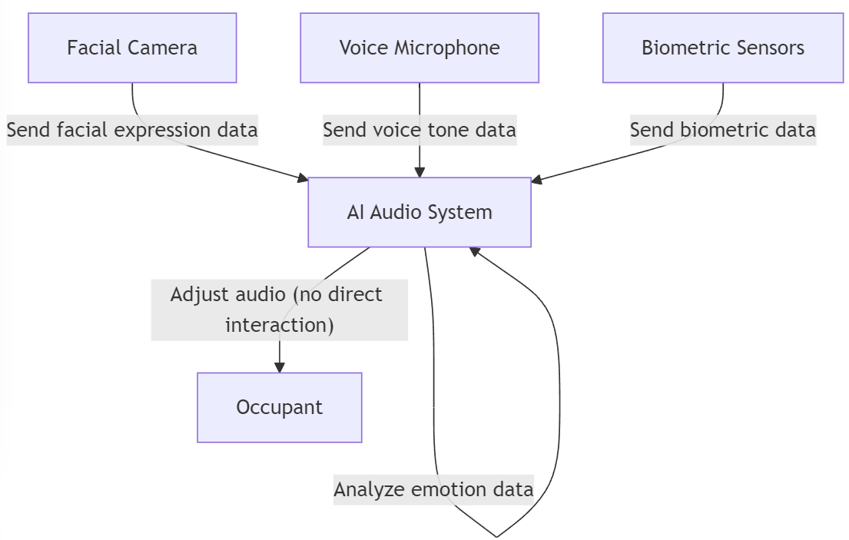

***flowchart TD***

***A[Facial Camera] -->|Send facial expression data| B[AI Audio System]***

***C[Voice Microphone] -->|Send voice tone data| B***

***D[Biometric Sensors] -->|Send biometric data| B***

***B -->|Analyze emotion data| B***

***B -->|"Adjust audio (no direct interaction)"| E[Occupant]***

c) **Providing content based on mood:**

* Mood-Content Mapping: The system will maintain a database mapping emotional states to appropriate content types.
* Dynamic Playlist Generation: Based on detected mood and preferences, the system will create real-time playlists.
* Seamless Source Switching: The system will switch between satellite and radio sources based on content availability and mood appropriateness.

***sequenceDiagram***

***participant O as Occupant***

***participant AS as AI Audio System***

***participant SR as Satellite Radio***

***participant TR as Terrestrial Radio***

***AS->>AS: Detect mood***

***AS->>AS: Select appropriate content***

***AS->>SR: Request specific content***

***SR-->>AS: Provide content***

***AS->>TR: Request specific content***

***TR-->>AS: Provide content***

***AS->>O: Play selected content***

***O->>AS: Provide feedback (optional)***

***flowchart TD***

***O[Occupant]***

***AS[AI Audio System]***

***SR[Satellite Radio]***

***TR[Terrestrial Radio]***

***AS -->|Detect mood| AS***

***AS -->|Select appropriate content| AS***

***AS -->|Request specific content| SR***

***SR -->|Provide content| AS***

***AS -->|Request specific content| TR***

***TR -->|Provide content| AS***

***AS -->|Play selected content| O***

***O -->|"Provide feedback (optional)"| AS***

d) **Learning user preferences:**

* Explicit Feedback: Allow users to rate content and create favorites.
* Implicit Feedback: Track listening duration, skips, and repeats to infer preferences.
* User Profiles: Create and update individual profiles for frequent occupants.
* **A diagram of a system

  Description automatically generated**Occupant Classification: Develop preference models for different occupant classes (e.g., age groups, frequent vs. occasional users).

***sequenceDiagram***

***participant O as Occupant***

***participant AS as AI Audio System***

***participant UP as User Preferences DB***

***O->>AS: Provide explicit feedback***

***AS->>AS: Track implicit feedback***

***AS->>UP: Update individual profile***

***AS->>UP: Update occupant class model***

***O->>AS: Make new request***

***AS->>UP: Retrieve updated preferences***

***UP-->>AS: Return preferences***

***AS->>O: Provide personalized content***

***flowchart TD***

***O[Occupant]***

***AS[AI Audio System]***

***UP[User Preferences DB]***

***O -->|Provide explicit feedback| AS***

***AS -->|Track implicit feedback| AS***

***AS -->|Update individual profile| UP***

***AS -->|Update occupant class model| UP***

***O -->|Make new request| AS***

***AS -->|Retrieve updated preferences| UP***

***UP -->|Return preferences| AS***

***AS -->|Provide personalized content| O***

1. **Automated Detection and Handling of Partner Failure**

Let's use pseudocode to show the automated detection and handling of a failure in the Satellite Radio partner:

This pseudocode demonstrates how the system would:

1. Regularly check the status of the satellite radio connection.
2. Detect a failure if the connection is lost or returns an error.
3. Handle the failure by logging the error, notifying the user, switching to terrestrial radio, and starting background reconnection attempts.
4. Continuously attempt to reconnect to the satellite radio in the background.
5. Notify the user and resume normal operation once the connection is re-established.

This approach ensures a seamless experience for the user, automatically handling partner failures and recovering when possible.